**BEAUTIFUL BEACHES**

|  |  |  |
| --- | --- | --- |
| Supervisor : | Sir AZHAR | |
| Batch : | 2210E | |
| Group : | BEAUTIFUL BEACHES | |
| Serial No. | Enrollment No. | Student Name. |
| 1. | 1424629 | KOMAL |
| 2. | 1425850 | Maryam |
| 3. | 1430182 | AYESHA |
| 4. | 1423593 | RAMEEL |

**Acknowledgement**

*The first, we would like to express my special thanks of gratitude to my teacher SIR AZHAR who helped a lot in finalizing this project within the limited time frame, valuable counseling and assistance for the accomplishment of this project.*

*Secondly, we would also like to thanks the e-project team at Aptech Head Office, who gave as the opportunity to do this interesting and wonderful project about BEAUTIFUL BEACHES*

*Thirdly, we also thank the e-project team for giving this task to us. Following are the benefits of this Project:*

* *Re-enforcement of skills happens in the experimental learning process.*
* *A mentor, ensuring that we do not get drifted, constantly guide us.*
* *It gives us a lot of confidence to face an interview as we have worked on a project. We can explain virtually everything on the subject we have learnt.*

**Synopsis**

*Most people love the beach and for different reasons. Perhaps it is all about the fun they get as they search for Hermit Crabs or simply to get a kick out of building sandcastles. So, even if your reason is just to exercise through the long runs by yourself or a partner, you will enjoy doing so on the best beaches in Asia.*

*Problems Definition*

*ntensive* *use of space and resources which may lead to poor water and environmental quality related to pollution, noise or species' disturbance; Building new marinas, piers or berths and impact on marine and coastal habitats; Impact on fish stocks.*

*Customer Requirement Specification (CRS)*

*To popularize his beautiful beaches, Mr. “A” has listed out the few*

*points which he wants to be their in website.*

*Here are list to be design in the project*

*1) Home page: should contain Menus like home, login,*

*contact us, feedback, adding recipe FAQ’s, Order the*

*books of the recipe.*

* *For Register page the customer can register with the*

*Site provided he/she makes the payment. The payment*

*For the members are*

*Scope Of The Work (Briefly)*

*The name of the project is beautiful beaches the software provides the customer various facilities .in this project we can easily maintain places of beach.*

*It’s gives complete information of beautiful beaches it’s name, price, and category etc. we can see the beach details before purchasing.*

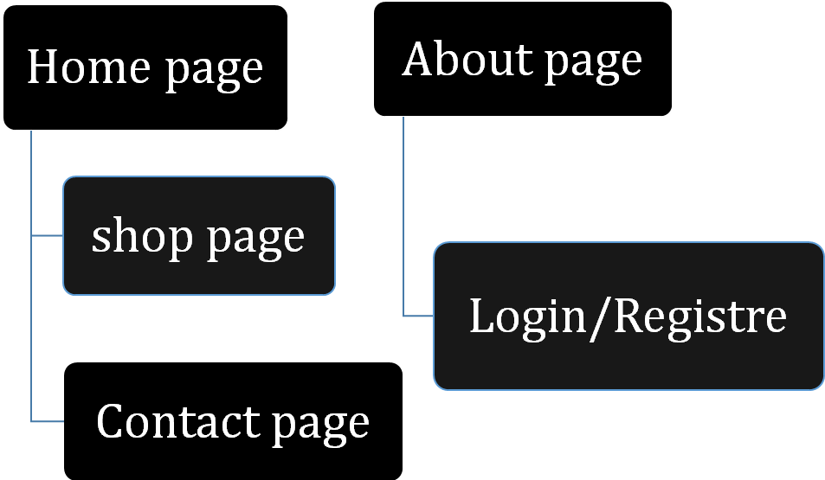

***Wireframes***

Layout

***Background Image***

***Bottom Layout***

***Get Into Touch***

***Submit***

***Your Massage***

***YourEmail***

***Your name***

***Login/Register page***

***Login/Register page***

***Login Register***

***Email***

***Login***

***Password***

***Email Address***

***Task Sheet***

***Contact Number***

***Register***

***Password***

***User name***

|  |  |  |  |  |  |  |
| --- | --- | --- | --- | --- | --- | --- |
| Project Ref.No:  Ep/Advertisement  Portal Management  System /01 | | ProjectTitle | Date Of preparation Of Activity Plan | | | |
| No. | ***Task*** | **B**  **E**  **A**  ***U***  **T**  **I**  **F**  **U**  **L**  **B**  **E**  **A**  **C**  **H**  **E**  **S** | ***Actual***  ***Start Date*** | ***Actual Days*** | ***Team-Mate***  ***Name*** | ***Status*** |
| 01. | ***Home page*** | 0  2  -  M  A  R  -  2  0  2  3 | 6  0  -  D  A  Y  S  - | All |  |
| 02. | ***Contact us page&feedback*** | Ayesha |  |
| 03. | ***About page*** | Komal |  |
| 04. | ***map*** | Maryam |  |
| 05. | ***Footer*** | Rameel |  |
| 06. | ***Documentation*** | Maryam  Rameel |  |